Medal prediction of country using numerical data

Project Id: 26

Name : Tarun Purohit
Class Roll Number:71
University Roll Number : 2028880
Section and Group: P G2

Name : Shobhit Rawat
Class Roll Number: 66
University Roll Number : 2028851
Section and Group: P G2

Name : Gaurav Dubey
Class Roll Number: 44
University Roll Number : 2028719
Section and Group: P G2

TABLE OF CONTENTS
- Problem Description 3
  - Dataset Description 3
  - Flow diagram 4
- Modules for Project Implementation…………………..…………………………5
  - Modules Used 5
  - Platform Used 6
- Machine Learning model/ Searching Technique used 7
- Evaluation metrics used 8
- Results and Visualizations 9
- Conclusion and Future Scope 11
- References 12

- Problem Description

The Olympic Medal Prediction System is a machine learning-based project developed to predict the medal count of different countries using historical Olympic numerical data. The primary objective of this project is to analyze previous Olympic performance records and estimate future medal counts with the help of regression models and data analysis techniques.
Olympic medal prediction is a challenging task because the performance of countries depends on multiple factors such as athlete participation, number of events, sports categories, historical performance trends, and overall country participation statistics. Manual prediction of medals becomes difficult due to the huge amount of Olympic data available. Machine learning helps automate this process by identifying hidden patterns and relationships within the dataset.

1.1 Dataset Description

The dataset used in this project is based on historical Olympic athlete event records. The dataset contains detailed information related to athlete participation and medal records from multiple Olympic years.
The original dataset contains features such as athlete name, sex, age, height, weight, team, NOC (National Olympic Committee code), games, year, season, city, sport, event, and medal status.
Before applying machine learning algorithms, several preprocessing operations were performed on the dataset. Missing values were handled, duplicate rows were removed, and unnecessary columns were filtered. Feature engineering techniques were used to create meaningful numerical features that improve model accuracy.
The important engineered features used in the project are:
Feature | Purpose
Athlete_Count | Represents the number of athletes participating from a country.
Event_Count | Represents the number of Olympic events participated in.
Total_Medals | Total medals won by the country.
Prev_Medals | Previous Olympic medal count used for trend analysis.
Medal_Rolling_Avg | Rolling average of medals over previous Olympic years.
Year | Olympic year used for historical trend analysis.

1.2 Flow Diagram
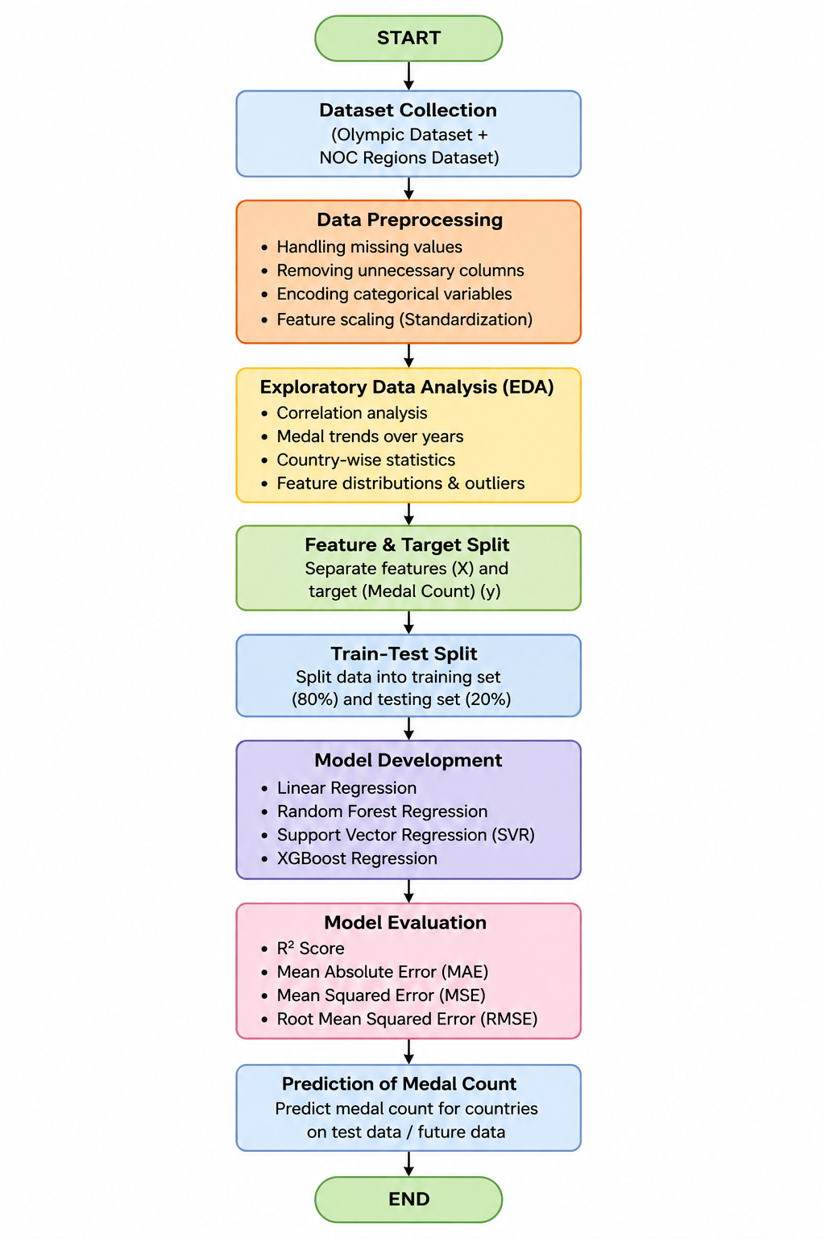

2. Modules for Project Implementation

2.1 Modules Used(mention all the inbuilt/ custom modules used and the purpose)

1. Pandas
Pandas module has been used for data manipulation, preprocessing, and analysis of the Olympic dataset. It helps in handling structured data efficiently using DataFrames.
Functions Used:
• pd.read_csv() – Reads CSV dataset into a pandas DataFrame.
• groupby() – Groups data country-wise and year-wise.
• merge() – Combines multiple DataFrames.
• fillna() – Handles missing values.
• dropna() – Removes null values.
• drop_duplicates() – Removes duplicate rows.
• rolling() – Calculates rolling averages.
• sort_values() – Sorts data values.
• reset_index() – Resets DataFrame index.
2. NumPy
NumPy module has been used for numerical operations and mathematical computations on arrays and datasets.
Functions Used:
• np.mean() – Calculates mean values.
• np.array() – Creates arrays.
• np.sqrt() – Calculates square root values.
• Mathematical and statistical operations on numerical data.
3. Matplotlib
Matplotlib module has been used for creating graphs, charts, and visualizations for data analysis.
Functions Used:
• plt.figure() – Creates a figure for plotting.
• plt.plot() – Creates line graphs.
• plt.scatter() – Creates scatter plots.
• plt.bar() – Creates bar graphs.
• plt.xlabel() – Labels x-axis.
• plt.ylabel() – Labels y-axis.
• plt.title() – Adds graph titles.
• plt.show() – Displays graphs.
4. Seaborn
Seaborn module has been used for advanced statistical visualizations and graphical representation of correlations.
Functions Used:
• sns.heatmap() – Creates correlation heatmaps.
• sns.barplot() – Creates bar plots.
• sns.scatterplot() – Creates scatter plots.
5. Scikit-learn (sklearn)
Scikit-learn library has been used for machine learning model training, feature selection, preprocessing, and evaluation.
train_test_split
Imported from:
from sklearn.model_selection import train_test_split
Used for splitting the dataset into training and testing datasets.
Function Used:
• train_test_split() – Splits data into train and test sets.
LinearRegression
Imported from:
from sklearn.linear_model import LinearRegression
Used for predicting medal counts using linear regression.
Functions Used:
• fit() – Trains the model.
• predict() – Predicts medal counts.
• score() – Evaluates model performance.
SequentialFeatureSelector
Imported from:
from sklearn.feature_selection import SequentialFeatureSelector
Used for backward feature selection to select important features.
Functions Used:
• fit() – Fits selector on data.
• get_support() – Returns selected features.
Metrics Module
Imported from:
from sklearn.metrics import accuracy_score, precision_score, recall_score, f1_score
from sklearn.metrics import r2_score, mean_squared_error
Used for evaluating machine learning models.
Functions Used:
• r2_score() – Measures regression accuracy.
• mean_squared_error() – Calculates prediction error.
• accuracy_score() – Classification accuracy metric.
• precision_score() – Precision metric.
• recall_score() – Recall metric.
• f1_score() – F1 evaluation metric.
RandomForestRegressor
Imported from:
from sklearn.ensemble import RandomForestRegressor
Used to improve prediction accuracy using ensemble learning.
Functions Used:
• fit() – Trains the model.
• predict() – Predicts outputs.
SVR (Support Vector Regression)
Imported from:
from sklearn.svm import SVR
Used for regression prediction using support vectors.
Functions Used:
• fit() – Trains the SVR model.
• predict() – Generates predictions.
5.7 StandardScaler
Imported from:
from sklearn.preprocessing import StandardScaler
Used for feature scaling and normalization.
Functions Used:
• fit_transform() – Scales training data.
• transform() – Scales testing data.
Pipeline
Imported from:
from sklearn.pipeline import Pipeline
Used to combine preprocessing and machine learning steps into a single workflow.
Functions Used:
• fit() – Fits complete pipeline.
• predict() – Predicts using pipeline.
KNeighborsRegressor
Imported from:
from sklearn.neighbors import KNeighborsRegressor
Used for predicting medal counts based on nearest neighboring data points.
Functions Used:
• fit() – Trains KNN model.
• predict() – Predicts outputs.
6. XGBoost
Imported from:
from xgboost import XGBRegressor
XGBoost module has been used for boosting-based regression and improving prediction accuracy.
Functions Used:
• fit() – Trains the XGBoost model.
• predict() – Predicts medal counts.

2.2 Platform Used: (mention all the platforms with the reason of using)

Jupyter Notebook

Jupyter Notebook has been used as the primary platform for implementing the machine learning project because it provides an interactive environment for writing and executing Python code step-by-step. It is highly suitable for data science and machine learning projects as it allows easy visualization of outputs, graphs, and model results within the same interface.

Jupyter Notebook supports data preprocessing, exploratory data analysis (EDA), model training, evaluation, and visualization efficiently. It also helps in debugging code quickly and testing different machine learning models interactively. Libraries such as Pandas, NumPy, Matplotlib, Seaborn, and Scikit-learn work smoothly in Jupyter Notebook, making it an ideal platform for developing the Olympic Medal Prediction System.

3. Machine Learning Model/ Searching Technique Used(Describe each ML model/ searching technique used)

1. Linear Regression: Linear Regression is a supervised machine learning algorithm used to predict numerical values. In this project, it predicts medal counts by establishing a linear relationship between input features and target values.
2. Random Forest Regression: Random Forest Regression is an ensemble learning algorithm that combines multiple decision trees. It improves prediction accuracy and reduces overfitting by averaging predictions from multiple trees.
3. Support Vector Regression (SVR): SVR is a regression technique that predicts continuous values while minimizing prediction error. It works efficiently for complex datasets and captures non-linear relationships between variables.
4. XGBoost Regression: XGBoost is a boosting-based ensemble learning model that builds trees sequentially to improve performance. It provides high accuracy and handles large datasets efficiently.

4. Evaluation metrics used (Describe each evaluation metric used along with formulae)

1. R² Score
R² Score measures how well the regression model explains the variance in the target variable (medal count values). A higher R² value indicates better prediction accuracy of the model.
Formula:
R² = 1 − (SSres / SStot)

2. Mean Absolute Error (MAE)
Mean Absolute Error calculates the average absolute difference between actual medal counts and predicted medal counts. Lower MAE values indicate better model performance.
Formula: MAE = (1/n) Σ |yi − ŷi|

3. Mean Squared Error (MSE)
Mean Squared Error measures the average squared prediction error generated by the model. It penalizes larger errors more heavily than smaller errors.
Formula: MSE = (1/n) Σ (yi − ŷi)²

4. Root Mean Squared Error (RMSE)
Root Mean Squared Error represents the standard deviation of prediction errors and indicates overall model performance. Lower RMSE values represent more accurate predictions.
Formula: RMSE = √MSE
5. Results and Visualizations

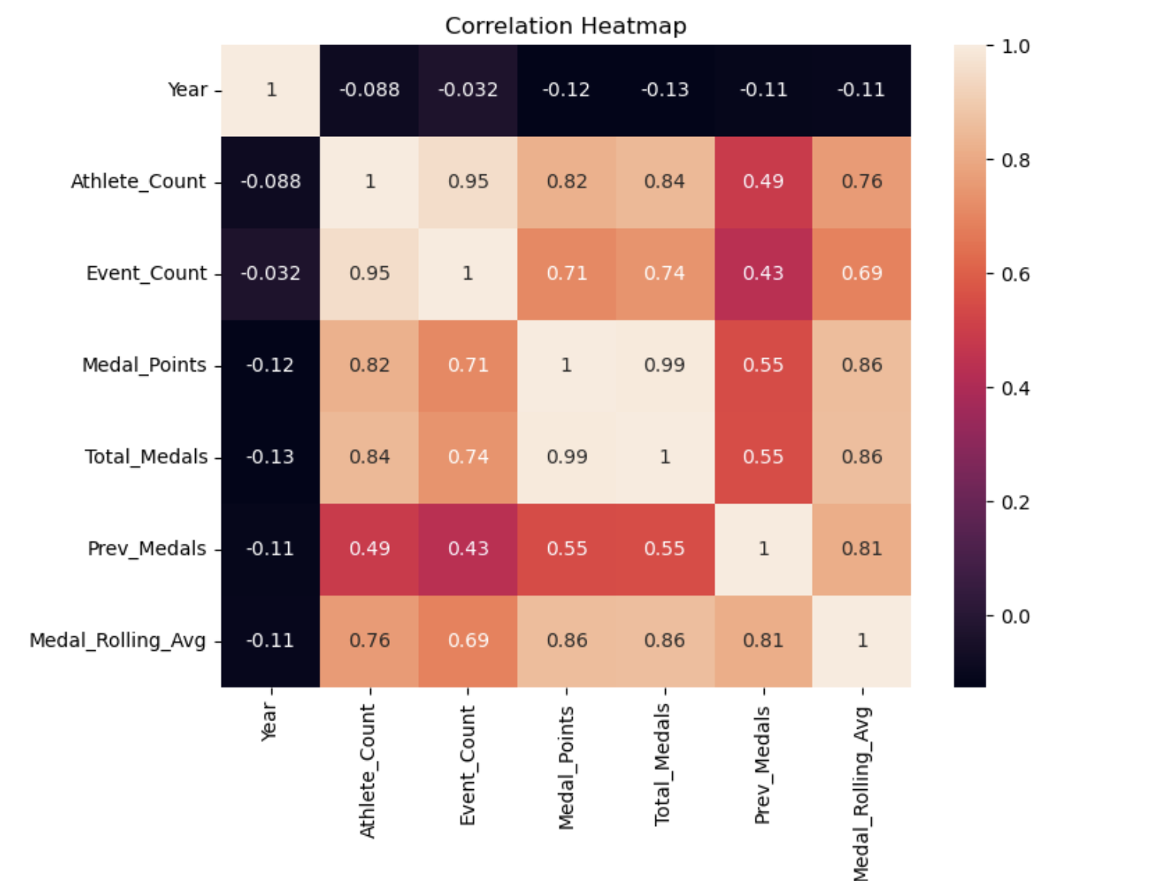
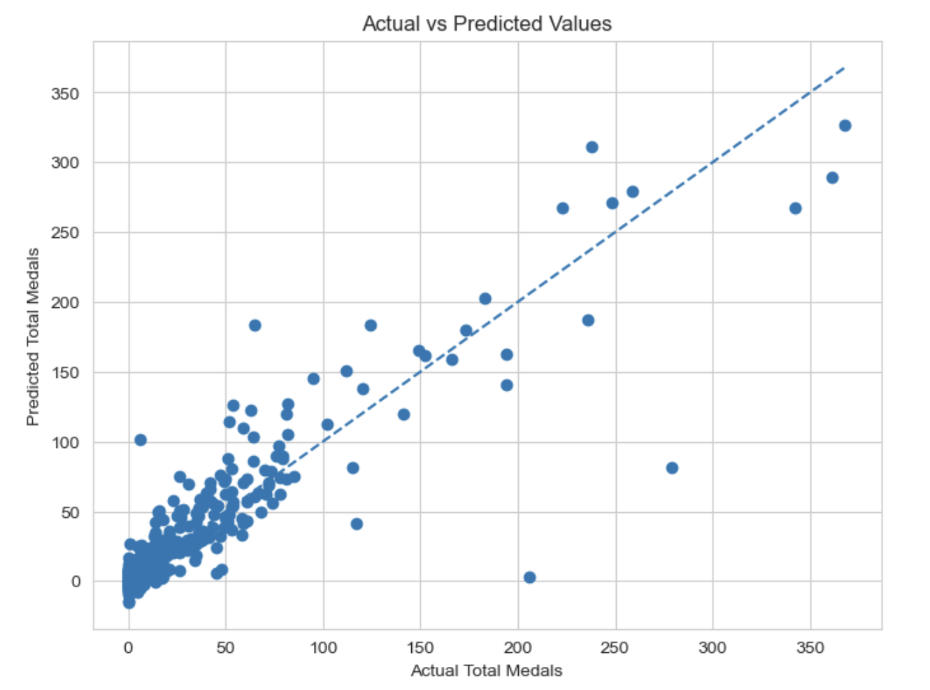

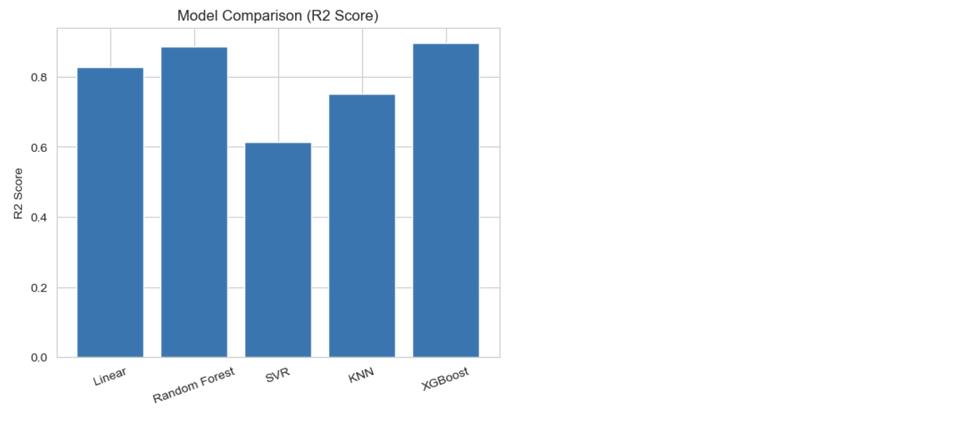

6. Conclusion and Future Scope:

The Olympic Medal Prediction System successfully demonstrates the application of machine learning for predicting medal counts using historical Olympic data. The project involved data preprocessing, feature engineering, regression modeling, and visualization techniques to improve prediction accuracy.
The developed system provides useful insights regarding Olympic performance trends and can assist sports analysts and researchers in understanding country-wise medal performance.
Future enhancements may include the use of deep learning techniques, real-time athlete statistics, economic and demographic factors, and deployment as a web-based application for interactive predictions.

7. References:
Books:
- Let Us Python – Yashavant Kanetkar

Online Resources:
  - GeeksforGeeks – https://www.geeksforgeeks.org/
  - TutorialsPoint – https://www.tutorialspoint.com/cprogramming/index.htm
  - Stack Overflow – https://stackoverflow.com

